Spry Web Browser
Final Project Report – http://svn.trollop.org/svn

Project Manager:
Doug Penner

Contributors:
Brendan Neva
Steffen L. Norgren
Eddie Zhang

COMP 4908 • BCIT • May 22, 2009

Table of Contents
Project Overview – Spry Web Browser 4
Current Situation 4
Problem – Existing Software Solutions 5
Envisioned Implementation 5
Implemented Ideas 5
What did not work (and why) 5
What did work 5
Final Implementation and Conclusion 6
WebKit/GTK+ 7
Implemented Functions 8
Functionality of Functions 9
Downloading & Compiling WebKit/GTK+ 10
Obtaining WebKit 10
Compiling WebKit/GTK+ on Ubuntu 8.04 11
Compiling WebKit/GTK+ on Ubuntu 9.04 12
Flags that Work 13
Flags that Cause Compilation to Fail 13
Flags Used During Testing 14
WebKit/GTK+ Library Dependencies 15
Disabling WebKit/GTK+ Features 16
Reimplementation of WebKit/GTK+ 16
Spry Web Browser 17
Required Libraries 17
Compilation 17
Gtk+ Documentation 17
Highlighting 18
Current Situation 18
Problem 18
Envisioned Implementation 18
Implementation Ideas 18
What did not work (and why) 18
What did work 18
Final Implementation and Conclusion 19
Context Menu 20
Current Situation 20
Problem 20
Envisioned Implementation 20
Implementation Ideas 20
What did not work (and why) 20
What did work 20
Final Implementation and Conclusion 21
Fullscreen 22
Current Situation 22
Problem 22
Envisioned Implementation 22
Implementation Ideas 22
What did work 22
Final Implementation and Conclusion 22
Thinbar 23
Current Situation 23
Problem 23
Envisioned Implementation 23
Implementation Ideas 23
What did work 23
Final Implementation and Conclusion 23
Command Line Options 24
Current Situation 24
Problem 24
Envisioned Implementation 24
Implementation Ideas 24
What did not work (and why) 24
What did work 24
Final Implementation and Conclusion 25
Buttons 26
Current Situation 26
Problem 26
Envisioned Implementation 26
Implementation Ideas 26
What did not work (and why) 26
What did work 26
Final Implementation and Conclusion 26
Frame-Buffer 27
Current Situation 27
Problem 27
Envisioned Implementation 27
Implementation Ideas 27
What did not work (and why) 27
What did work 27
Final Implementation and Conclusion 27
Benchmarking 28
Memory 28
Compared to other Browsers 28
Problems 28
Speed 29
Compared to Other Browsers 29
Problems 29
SunSpider Test Results: 30
CelticKane Test Results: 34
Conclusion 35

Project Overview – Spry Web Browser

Current Situation
Current browser software for desktop PC's are extremely resource intensive. Firefox and Internet Explorer require large amounts of RAM, disk space, and CPU cycles in order to function well. Therefore, due to the nature of TechSol's products (low power, small foot print), these existing browsers do not provide a workable solution.
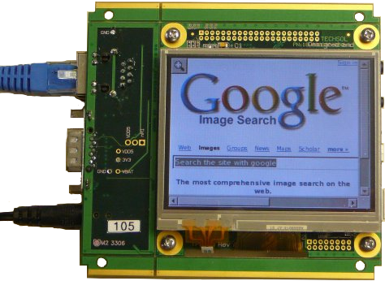
In the embedded space there are many open source browsers but all with minimal functionality and ongoing development. There are commercial browsers available, targeted at the embedded space (Opera), but all involve ongoing licensing fees.
WebKit is the one open source browser project that has; broad based support from the open source community, significant ongoing development, a focus towards hand held devices (low power, small footprint), both open source and commercial applications based on it, and, industry support with major contributions (Apple: Apples Safari browser, for the desktop and the iphone have been developed using WebKit).

Problem – Existing Software Solutions
- Resource intensive
- Some require ongoing licensing fees
- Large memory footprint
- Too many unnecessary features
- Unfriendly to touch-screen interfaces

Envisioned Implementation
- WebKit based browser
- Reimplement only the features WebKit/GTK+ that are absolutely necessary
- Provide command-line options to configure browser sessions
- Absolute minimum feature set

Implemented Ideas
- WebKit based browser
- Implemented WebKit/GTK+ as our API
- Provided a completely command-line configurable application
- Minimum feature set achieved via disabling WebKit/GTK+ features at compile time

What did not work (and why)
- Reimplementing only necessary features of WebKit/GTK+ – After digging through the source code of WebKit/GTK+, we found that it wouldn't be feasible to do a complete reimplementation of the project within the time-frame of this project.

What did work
- Creation of a WebKit based browser
- Using WebKit/GTK+ as our API
- Providing a completely command-line configurable solution.
- Reducing the browser's features to a minimum
- Reducing WebKit/GTK+ to a minimum through compile-time flags

Final Implementation and Conclusion
The final implementation of the Spry web browser uses WebKit/GTK+, which is a port of WebKit for Gtk+ on *NIX platforms. In theory, the Spry web browser could be compiled on Mac OS X or even Windows, given that the appropriate libraries and environments were installed.
When we initially started working on this project, we decided that the optimal solution would be one in which we actually took WebKit/GTK+ itself apart and only reimplemented the features contained therein that were absolutely necessary. By doing it this way, we could remove all the extra features that would not be used on a touch-screen as well as implement features that WebKit/GTK+ wouldn't be able to manage; such as click+drag to scroll the window.
Unfortunately, WebKit/GTK+ is very tightly integrated into the WebKit core, which made such a solution somewhat outside the scope of a 4-week project. As such, we decided to simply make use of the WebKit/GTK+ API in our solution.

WebKit/GTK+
WebKit/GTK+ is the new GTK+ port of the WebKit, an open-source web content engine that powers numerous applications such as web browsers, email clients, feed readers, web and text editors.
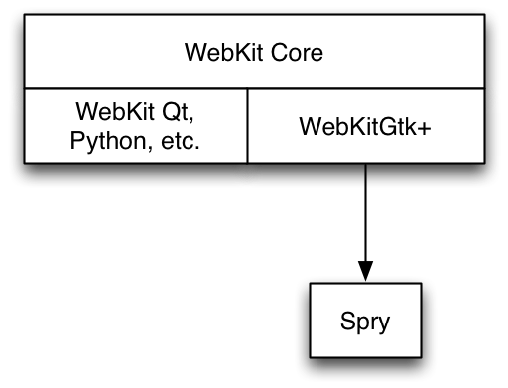
The WebKit/GTK+ port of WebKit is built upon the main WebKit Core and acts as somewhat of a go-between for Gtk+ and the WebKit Core. There are other WebKit projects that are also built upon the WebKit core, which include WebKit for Qt, Python, Cocoa, etc.
Spry is built upon WebKit/GTK+, which drastically reduced the amount of code complexity needed to build a fully-functional application, however, this also reduces the amount of control we have over what features of the WebKit Core to which the Spry web browser has access.
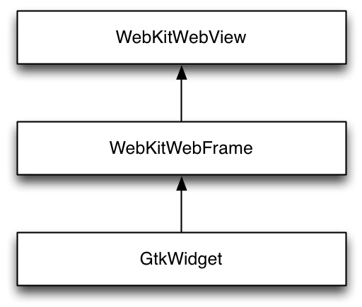
The object model for the actual web-browser contents in Spry is a simply hierarchy, similar to the API layers for WebKit/GTK+. The WebKitWebView object is the object that actually contains the web page content that a user actually sees. The WebKitWebView object is contained within a WebKitWebFrame object, which is subsequently contained within a standard GtkWidget object.

Implemented Functions
Because we decided to create the Spry web browser using the WebKit/GTK+ API, we actually only ended using three basic functions from the API. The remaining functions within the Spry web browser are all used to manage command-line options and GUI elements.
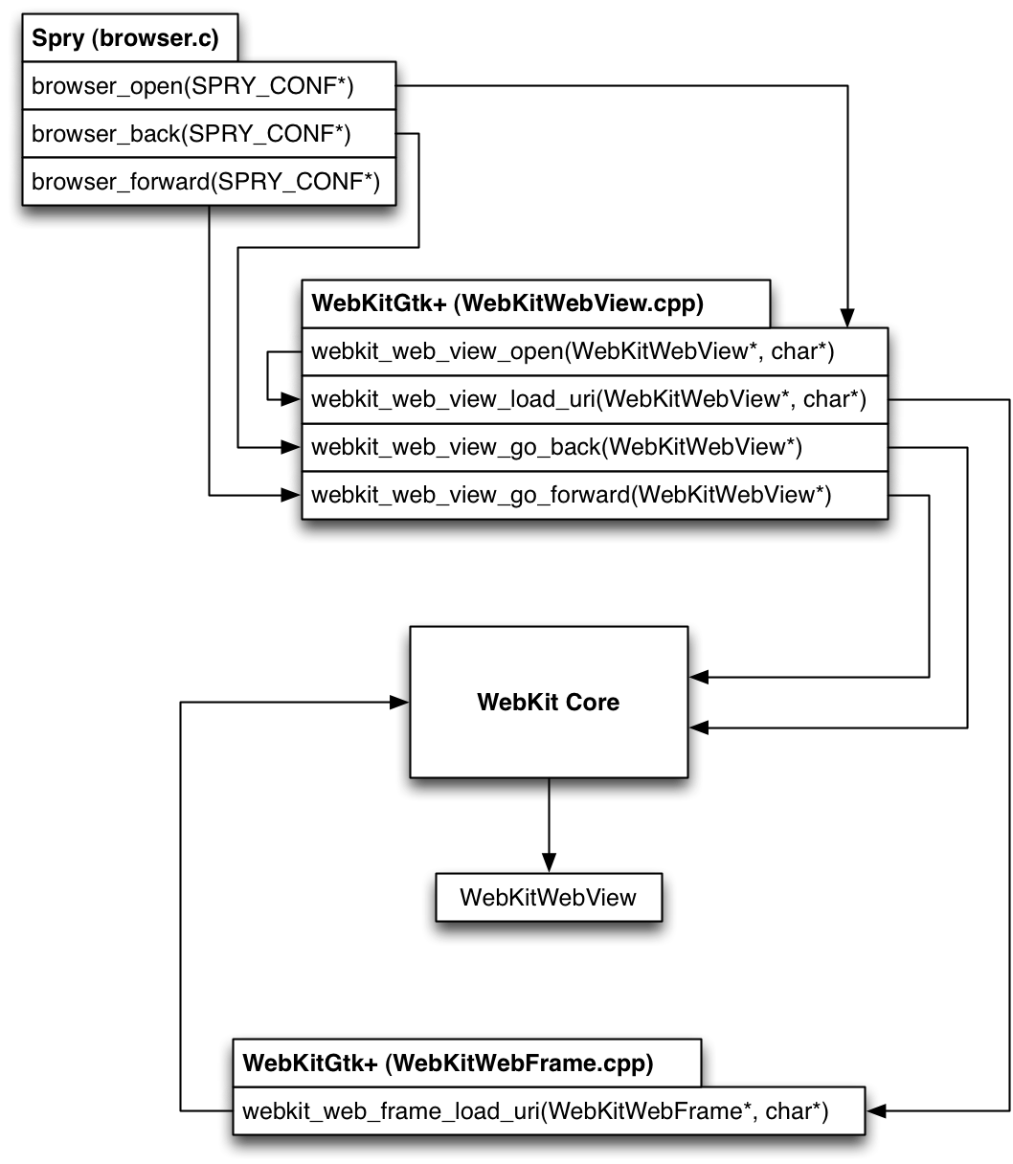

Functionality of Functions
As we mentioned above, very few of the WebKit/GTK+ API functions were actually needed to create a working web browser. Below I shall trace through what each function does.
Opening a new web page:
- browser_open(SPRY_CONF*) – Passes the WebKitWebView object contained within the SPRY_CONF struct and requested URI to the webkit_web_view_open() function.
- webkit_web_view_open(WebKitWebView*, char*) – This function has actually been depreciated in newer versions of WebKit/GTK+, which is why this function only serves to pass the WebKitWebView object and URI to the webkit_web_view_load_uri() function.
- webkit_web_view_load_uri(WebKitWebView*, char*) – This is the actual function that serves as a connector between WebKit/GTK+ and the WebKit Core. This function simply calls the appropriate WebKit Core object function with the WebKitWebFrame object (remember that WebKitWebFrame contains the WebKitWebView object) and URI string. The WebKit Core then loads the requested page data into the WebKitWebFrame, which is then immediately updated within the GUI.
Going backwards in the browser history:
- browser_back(SPRY_CONF*) – Passes the WebKitWebView object contained within the SPRY_CONF struct to webkit_web_view_go_back() function.
- webkit_web_view_go_back(WebKitWebView*) – Much like with browser_open(), the WebKit/GTK+ API simply passes the WebKitWebFram contained within WebKitWebView to the WebKit Core to be populated with the previous web page's data.
Going forwards in the browser history:
- browser_forward(SPRY_CONF*) – Passes the WebKitWebView object contained within the SPRY_CONF struct to webkit_web_view_go_forward() function.
- webkit_web_view_go_forward(WebKitWebView*) – Passes the WebKitWebFram contained within WebKitWebView to the WebKit Core to be populated with the next web page's data.

Downloading & Compiling WebKit/GTK+
We first started working with WebKit SVN repository, however, we soon found out that compiling from that repository would take hours and create a very large WebKit library file. As such, we have switched to the latest current release of WebKitGtk+, which can be obtained from the WebKitGtk+ project website (http://webkitgtk.org/).

Obtaining WebKit
There are several options for obtaining WebKit/GTK+, however, I highly suggest the first option, as checking out WebKit from the SVN or Git trunk can be very time consuming. Additionally, the download of WebKit/GTK+ 1.1.7 has all of the non GTK+ related code removed from the source, speeding up compile times tremendously while also reducing the resultant library size.
- Download the current release of WebKit/GTK+:
WebKit/GTK+ 1.1.7 - http://www.webkitgtk.org/webkit-1.1.7.tar.gz
- Or checkout the current development version of WebKit from SVN:
svn co http://svn.webkit.org/repository/webkit/trunk
- Alternatively there is a git mirror for your convenience:
git clone git://git.webkit.org/webkit

Compiling WebKit/GTK+ on Ubuntu 8.04
Once you have obtained and extracted WebKit/GTK+, you'll need to make sure you have the all of the required packages installed before being able to compile.
For Ubuntu 8.04, install the following packages:
- build-essential
- gnome-common
- pkg-config
- bison
- flex
- gperf
- libjpeg-dev
- libpng12-dev
- libglib2.0-dev
- libicu-dev
- libxml-dev
- libxslt1-dev
- libpango1.0-dev
- libenchant-dev
- libgtk2.0-dev
- libxt-dev
- libsqlite3-dev
- gtk-doc-tools
There is one snag with Ubuntu 8.04, as the version of libsoup is too old to work with the current release of WebKit/GTK+. As such, you will need to download the latest version of libsoup and compile and install that before continuing with compiling WebKit/GTK+ itself.
Obtaining & Compiling libsoup >= 2.25.91:
- git clone git://git.gnome.org/libsoup
- cd libsoup
- ./autogen.sh –without-gnome
- sudo make install
Compiling libsoup with the --without-gnome flag is important, otherwise libsoup will require you to install libraries that are unavailable to Unbutu 8.04.

Compiling WebKit/GTK+ on Ubuntu 9.04
After having obtained and extracted WebKit/GTK+, you'll need to make sure you have the all of the required packages installed before being able to compile.
For Ubuntu 9.04, install the following packages:
- build-essential
- gnome-common
- pkg-config
- bison
- flex
- gperf
- libjpeg-dev
- libpng12-dev
- libglib2.0-dev
- libicu-dev
- libxml2-dev
- libxslt1-dev
- libpango1.0-dev
- libenchant-dev
- libgtk2.0-dev
- libxt-dev
- libsoup2.4-dev
- libsqlite3-dev
- gtk-doc-tools

Flags that Work
- --with-target=x11 – Sets the build target to X11
- --with-font-backend=freetype – Freetype isn't as large as using pango
- --enable-optimizations – Enables all compiler optimizations
- --enable-fast-malloc – Enalbles the use of fast mallocs
- --enable-jit – Enables the JIT compiler for JavaScript.
This is what makes WebKit's JS so fast
- --enable-static – Enables static compilation
- --disable-largefile – Disables support for large files
- --disable-libtool-lock – Disables libtool locking. This speeds up
compilation, but may break parallel builds.
- --disable-debug – We don't want debugging enabled
- --disable-dashboard-support – OS X specific support
- --disable-offline-web-applications – Disables storing web-applications for
offline use
- --disable-dom-storage – Disables HTML5 DOM storage
- --disable-icon-database – Disables sqlite icon database
- --disable-video – Disables HTML5 video support
- --disable-xpath – Disables XML Xpath support
- --disable-xslt – Disables XML stylesheet support
- --disable-geolocation – Disables geolocation support
- --disable-wml – Disables Wireless Markup Language
- --disable-web-workers – Disables offloading JavaScript to a thread
- --disable-coverage – Disables code coverage support
- --disable-svg-animation – Disables experimental SVG animation
- --disable-svg-filters – Disables experimental SVG filters
- --disable-svg-fonts – Disables experimental SVG fonts
- --disable-svg-foreign-object – Disables experimental SVG objects
- --disable-svg-as-image – Disables experimental SVG as image
- --disable-svg-use-element – Disables experimental SVG as element

Flags that Cause Compilation to Fail
- --with-target=directfb – Attempts to compile WebKit/GTK+ with
frame-buffer support
- --disable-database – Disables use of sqlite databases
- --disable-svg – Disables SVG support
- --disable-javascript-debugger – Disables the JavaScript debugger

Flags Used During Testing
After several days of compiling WebKit/GTK+ over and over, we were able to successfully build WebKit/GTK+ using the following compile-time flags:
./autogen.sh –with-target=x11 \
--with-font-backend=freetype \
--enable-optimizations \
--enable-fast-malloc \
--enable-jit \
--enable-static \
--disable-largefile \
--disable-libtool-lock \
--disable-debug \
--disable-dashboard-support \
--disable-offline-web-applications \
--disable-dom-storage \
--disable-icon-database \
--disable-video \
--disable-xpath \
--disable-xslt \
--disable-geolocation \
--disable-wml \
--disable-web-workers \
--disable-coverage \
--disable-svg-animation \
--disable-svg-filters \
--disable-svg-fonts \
--disable-svg-foreign-object \
--disable-svg-as-image \
--disable-svg-use-element
These flags basically disable every feature of WebKit/GTK+ that we didn't foresee as being used or needed for a web browser running in an embedded environment. Our testing has shown that disabling all these WebKit/GTK+ features have no impact on normal web browsing. All of the pages that we tested worked as expected, including the test pages that TechSol provided.

WebKit/GTK+ Library Dependencies
Based on using the compile-time flags listed above, WebKit/GTK+ has the following library dependencies:
-rw-r--r-- 1 root root 42700 2008-10-10 12:36 /lib/libgcc_s.so.1
-rw-r--r-- 1 root root 95948 2008-02-29 14:29 /lib/libselinux.so.1
-rwxr-xr-x 1 root root 1364388 2008-09-12 07:33 /lib/tls/i686/cmov/libc.so.6
-rw-r--r-- 1 root root 9684 2008-09-12 07:33 /lib/tls/i686/cmov/libdl.so.2
-rw-r--r-- 1 root root 149328 2008-09-12 07:33 /lib/tls/i686/cmov/libm.so.6
-rwxr-xr-x 1 root root 112354 2008-09-12 07:33 /lib/tls/i686/cmov/libpthread.so.0
-rw-r--r-- 1 root root 30624 2008-09-12 07:33 /lib/tls/i686/cmov/librt.so.1
-rw-r--r-- 1 root root 104756 2008-03-10 15:39 /usr/lib/libatk-1.0.so.0
-rw-r--r-- 1 root root 396284 2008-06-04 08:45 /usr/lib/libcairo.so.2
-rw-r--r-- 1 root root 23132 2007-12-09 12:08 /usr/lib/libenchant.so.1
-rw-r--r-- 1 root root 131652 2007-12-05 09:51 /usr/lib/libexpat.so.1
-rw-r--r-- 1 root root 172592 2008-02-28 09:22 /usr/lib/libfontconfig.so.1
-rw-r--r-- 1 root root 447292 2009-04-22 11:24 /usr/lib/libfreetype.so.6
-rw-r--r-- 1 root root 94868 2008-09-26 06:28 /usr/lib/libgdk_pixbuf-2.0.so.0
-rw-r--r-- 1 root root 536872 2008-09-26 06:28 /usr/lib/libgdk-x11-2.0.so.0
-rw-r--r-- 1 root root 394976 2009-03-12 17:43 /usr/lib/libgio-2.0.so.0
-rw-r--r-- 1 root root 723948 2009-03-12 17:43 /usr/lib/libglib-2.0.so.0
-rw-r--r-- 1 root root 10116 2009-03-12 17:43 /usr/lib/libgmodule-2.0.so.0
-rw-r--r-- 1 root root 245296 2009-03-12 17:43 /usr/lib/libgobject-2.0.so.0
-rw-r--r-- 1 root root 14232 2009-03-12 17:43 /usr/lib/libgthread-2.0.so.0
-rw-r--r-- 1 root root 3628152 2008-09-26 06:28 /usr/lib/libgtk-x11-2.0.so.0
-rw-r--r-- 1 root root 86160 2007-10-23 22:08 /usr/lib/libICE.so.6
-rw-r--r-- 1 root root 11175612 2009-03-25 10:30 /usr/lib/libicudata.so.38
-rw-r--r-- 1 root root 1428992 2009-03-25 10:30 /usr/lib/libicui18n.so.38
-rw-r--r-- 1 root root 1203328 2009-03-25 10:30 /usr/lib/libicuuc.so.38
-rw-r--r-- 1 root root 125316 2007-10-01 07:36 /usr/lib/libjpeg.so.62
-rw-r--r-- 1 root root 244900 2009-05-05 12:12 /usr/lib/libpango-1.0.so.0
-rw-r--r-- 1 root root 34904 2009-05-05 12:12 /usr/lib/libpangocairo-1.0.so.0
-rw-r--r-- 1 root root 158380 2009-05-05 12:12 /usr/lib/libpangoft2-1.0.so.0
-rw-r--r-- 1 root root 157240 2008-07-09 10:23 /usr/lib/libpcre.so.3
-rw-r--r-- 1 root root 164328 2008-04-07 13:01 /usr/lib/libpixman-1.so.0
-rw-r--r-- 1 root root 141452 2009-03-05 11:34 /usr/lib/libpng12.so.0
-rw-r--r-- 1 root root 28092 2007-05-16 02:07 /usr/lib/libSM.so.6
-rw-r--r-- 1 root root 410036 2007-10-24 09:04 /usr/lib/libsqlite3.so.0
-rw-r--r-- 1 root root 970680 2008-10-10 12:39 /usr/lib/libstdc++.so.6
-rw-r--r-- 1 root root 944876 2008-03-11 13:33 /usr/lib/libX11.so.6
-rw-r--r-- 1 root root 6988 2007-04-27 09:03 /usr/lib/libXau.so.6
-rw-r--r-- 1 root root 93832 2008-03-11 13:31 /usr/lib/libxcb.so.1
-rw-r--r-- 1 root root 4172 2008-03-11 13:31 /usr/lib/libxcb-xlib.so.0
-rw-r--r-- 1 root root 6716 2007-12-06 03:54 /usr/lib/libXcomposite.so.1
-rw-r--r-- 1 root root 33152 2007-10-24 00:39 /usr/lib/libXcursor.so.1
-rw-r--r-- 1 root root 5992 2007-04-27 09:01 /usr/lib/libXdamage.so.1
-rw-r--r-- 1 root root 16616 2007-04-27 09:01 /usr/lib/libXdmcp.so.6
-rw-r--r-- 1 root root 56156 2007-07-24 01:00 /usr/lib/libXext.so.6
-rw-r--r-- 1 root root 14128 2007-04-27 08:59 /usr/lib/libXfixes.so.3
-rw-r--r-- 1 root root 6464 2007-07-25 01:01 /usr/lib/libXinerama.so.1
-rw-r--r-- 1 root root 29432 2007-10-24 00:43 /usr/lib/libXi.so.6
-rw-r--r-- 1 root root 1171112 2008-11-18 11:16 /usr/lib/libxml2.so.2
-rw-r--r-- 1 root root 22136 2007-10-24 01:31 /usr/lib/libXrandr.so.2
-rw-r--r-- 1 root root 30544 2007-10-24 01:31 /usr/lib/libXrender.so.1
-rw-r--r-- 1 root root 326564 2007-05-21 05:27 /usr/lib/libXt.so.6
-rw-r--r-- 1 root root 81240 2007-11-15 04:08 /usr/lib/libz.so.1
-rwxr-xr-x 1 root root 824448 2009-05-22 01:24 /usr/local/lib/libsoup-2.4.so.1
What we have failed to completely understand is why after disabling features such as XML and pango, they remain in the ldd listings for libwebkit. However, despite this large listing of libraries, I am sure that a fair amount of these libraries wouldn't be required when doing a cross compile.

Disabling WebKit/GTK+ Features
What we discovered throughout the course of creating the Spry web browser is that it is very difficult to disable features implemented within WebKit/GTK+ that we don't necessarily want.
For example, we struggled for a long time with how to disable the ability for the user to select and highlight text, as this could lead to undesirable behaviour in a touch-screen environment. Unfortunately, all of our attempted workarounds caused the browser to become unusable.

Reimplementation of WebKit/GTK+
Because of the above limitations, we came to the conclusion that our original development plan would have been the most optimal for this situations. It was also, unfortunately, beyond the scope of time that we had available for working on this project.
However, despite the limitation of time, I believe that it is entirely possible to reimplement only the necessary features of WebKit/GTK+ within a reasonable time-frame; perhaps a couple of months.
I therefore suggest that if TechSol is interested in further optimization of the Spry web browser, that they consider developing along this route.

Spry Web Browser

Required Libraries
The only library that the Spry browser itself requires is:
-rwxr-xr-x 1 root root 14285101 2009-05-22 03:20 /usr/local/lib/libwebkit-1.0.so.2
So basically, as long as the requirements for libwebkit are met, Spry shouldn't have any issues running on any platform.

Compilation
To compile the Spry web browser, do the following:
- ./autogen.sh
- make
- sudo make install
That should be all that is required to have a successful compile of the Spry web browser.

Gtk+ Documentation
Throughout the development of the Spry web browser, we adhered to the Gtk-Doc standards such that easy to read HTML documentation could be produced for the code on demand.
Generating Gtk-Docs:
- In the Spry source directory, enter ./mkdoc.sh
- cd docs
- Open index.html
More information about Gtk-Doc can be found at:
- http://library.gnome.org/devel/gtk-doc-manual/stable/

Highlighting

Current Situation
WebKit, like all modern browsers, has the ability to select text, graphics and other elements on a screen for the purpose of copying them.

Problem
- When you are using a touch screen, there is a likelihood for the user to accidentally move their finger a tiny amount and initiate a “select” instead of the desired “click”.

Envisioned Implementation
- Disable highlighting all together
- possibly implement “drag to scroll”.

Implementation Ideas
- Disable highlighting in WebKit, possibly before or at compile time
- Call WebKit with the features disabled.
- Capture and steal mouse-drag events
- Capture all mouse actions, and only use those we want
- Handle highlighting at the website level (Javascript + CSS)

What did not work (and why)
- Removing modules from WebKit proved to be very complicated and time consuming.
- WebKit's compile flags are not very numerous and none of them allow you to enable or disable UI features, only certain environment settings.
- WebKit does not allow you to disable features through function arguments or settings.
- If you try to capture mouse-drags, you end up capturing all mouse events and it is very difficult to release a mouse-click back to it's original target. This is especially true with WebKit's web_view.

What did work
- We were able to handle the unwanted mouse events at the website level (Javascript).
- Javascript was able to deselect all the text when it detected a “drag” event.

Final Implementation and Conclusion
In the end, we ended up injecting some Javascript into each page. The script would detect a mouse-down, then if no mouse-up occurred for a specified period of time (~250ms), it would call a “select-none” function and cancel the selection.

Context Menu

Current Situation
The closest thing we have to a context menu is the “back/forward/stop/reload” menu provided by WebKit when you right-click.

Problem
- The menu is limited (forward/back/stop/reload)
- The menu changes depending on what you clicked on (text/image/background/link/etc)
- The menu is small, making the options hard to hit on a small screen
- Touchscreens (typically) have no right-click.

Envisioned Implementation
- Double-click activates the menu
- The buttons are as big as possible and resize with the window, making them easier to hit
- The context menu is static and incorporates application options (full-screen, minimize, close)

Implementation Ideas
- Disable highlighting in WebKit, possibly before or at compile time
- Call WebKit with the features disabled.
- Capture and steal mouse-drag events
- Capture all mouse actions, and only use those we want
- Handle highlighting at the website level using Javascript.

What did not work (and why)
- When attempting to capture a right-click, we ran into the problem where it would also capture a single left-click and we could not give it back to WebKit. This rendered it impossible to click on links!

What did work
- We made the context menu activated by a button. This was a work-around, but at least it works.
- The buttons are on a 9x9 grid, making them very easy to hit on almost any screen size.

Final Implementation and Conclusion
The context menu's design is very solid and is quite useful and easy to use. Trying to capture a specific mouse action on the other hand has proven time and time again to be very annoying and difficult to do without negatively affecting other parts of the UI (such as WebKit).

Fullscreen

Current Situation
Most web browsers these day have a full-screen option that still shows a toolbar at the top for navigation.

Problem
- The full-screen mode still has the bar at the top, which is not very useful in a lot of applications.
- A hotkey or menu is required to enter or leave full-screen mode.

Envisioned Implementation
- Fullscreen removes all toolbars and buttons to take advantage of 100% screen real-estate.
- Entering and leaving full-screen is easy and intuitive.
- Fullscreen mode can be specified and configured at the command line.

Implementation Ideas
- Add a command line switch to start in full-screen
- Enable and disable full-screen using the context menu.
- Have full-screen available with or without the toolbar at the top.

What did work
- The command line argument was very easy to do (-f switch).
- The toolbar can be toggled via the context menu or the thinbar at the top.
- 100% screen real-estate is possible if you disable the thinbar or both the context menu and toolbar.

Final Implementation and Conclusion
Fullscreen turned out to be very easy to do. Gtk handles the actual full-screen part quite nicely and toggling the toolbar is done using it's own toggle, so that didn't even need to be implemented.

Thinbar

Current Situation
Toolbars are static sizes and can sometimes be resized via configuration windows.

Problem
- Toolbars take up too much room, especially on small displays.
- The toolbar should be able to be shrunken to a few pixels, or hidden completely very easily.

Envisioned Implementation
- Implement a “thinbar” that can be shown instead of a toolbar.
- The thinbar will activate the toolbar when clicked.
- If the toolbar is disabled, it will activate the context menu.
- If the toolbar and context menu are disabled, the thinbar will toggle full-screen
- The size of the thinbar can be configured via command line.
- The thinbar can be completely disable via command line.

Implementation Ideas
- Hide the thinbar when either the context menu or toolbar are visible.

What did work
- You can have the toolbar, the thinbar or the context menu visible, but not multiple (by design).
- The thinbar will activate the first enabled feature in order (toolbar, context menu, full-screen).
- The thinbar's height is configurable via command line (-T <size>).
- If the thinbar's height is set to 0 (-T 0), then it will be completely disabled.

Final Implementation and Conclusion
The thinbar is only present if it is not disabled, at least the toolbar or context menu are enable and they are both hidden. When the thinbar is clicked, it checks for the first feature that is enable and activates it. The order is toolbar, context menu and full-screen Since full-screen is always an option, the only way to completely disable the thinbar is via command line (-T 0).

Command Line Options

Current Situation
Current browsers allow you to specify certain parameters via command line such as URL, profile and full-screen/maximized/restored.

Problem
- You can not specify the size of the window.
- You can not enable or disable features (toolbar, context menu, thinbar, resizing, scrolling, etc).

Envisioned Implementation
- Each implemented feature has a command line switch to enable or disable it.
- All dimension and mode aspects of the window such as full-screen and size can be specified.
- The URL can be specified, with http:// appended to the front if required.

Implementation Ideas
- The application defines it's starting values by reading the command line arguments.
- The program ensures that http:// is at the beginning of the URL
- If no URL is specified, it defaults to localhost.
- Make the additional arguments very easy to add.

What did not work (and why)
- getopt requires a single letter version for each switch. This limits the number of intuitive switches that can be used.
- We did not have enough time to enable or disable individual toolbar and context menu buttons via command line.

What did work
- Window size can be specified using -x <size> and -y <size>
- Fullscreen can be enabled using -f
- The URL is specified with -u <URL>
- The application automatically adds http:// to the front of the URL if it is not present.
- New command line switches can be added very easily with minimal code.

Final Implementation and Conclusion
Almost all imaginable options are available as command line arguments. This allows you to create a launcher than opens an almost completely customized UI for the user to use.

Buttons

Current Situation
Toolbars are designed to stretch and shrink in order to contain the icons and buttons they hold.

Problem
- Small icons are hard to hit on small touchscreens.
- Not all screens are the same size, especially touchscreens.
- We want to make the toolbar sizes customizable at launch time.
- We do not want to use different icon sets for different sizes.

Envisioned Implementation
- The size of the toolbar itself is specified.
- The icons inside resize to take up as much room inside the toolbar as possible.

Implementation Ideas
- Use scallable vector graphics (SVG) for all icons.
- Have buttons take up as much space as possible, making them easy to click.
- Make the icons take 100% of the button space.

What did not work (and why)
- Embedding SVG's directly into a button does not allow it to resize automatically.

What did work
- Buttons scale to largest possible size when added using the “scale” flag.
- Adding a draw area to the button, then having the draw area handle the icon allowed for the desired resizing effect.

Final Implementation and Conclusion
The buttons work exactly as we had hoped, with the exception of being greyed out when unavailable. The icons resize as we had wanted, but we pretty much had to rewrite the icon drawing manually since the default method does not resize the icons automatically.

Frame-Buffer

Current Situation
Gtk uses the X server to handle to draw its windows and handles the mouse and keyboard.

Problem
- The X server, while very well written, does use some unnecessary resources.
- If the device is designed to be a single-use website viewer, why use a window manager?

Envisioned Implementation
- Have the device boot directly into command line mode.
- Have the application able to run without an X server, using the frame-buffer directly.

Implementation Ideas
- Compile Gtk and WebKit to use the frame-buffer directly without needing the X server.

What did not work (and why)
- WebKit does not compile with the frame-buffer option specified.
- Gtk can not render WebKit in frame-buffer mode if WebKit was compiled to use the X server.

What did work
- Gtk compiled just fine with the frame-buffer option.

Final Implementation and Conclusion
We had to scrap the idea since WebKit would not compile with the frame-buffer option and Gtk could not embed WebKit unless they were both using the same rendering system (frame-buffer vs X server).

Benchmarking

Trying to find programs to benchmark Spry was a problem. There are a ton of programs out there but they all seem to be checking the size of the program which we already had. In the end we mainly just checked the memory and speed of the program. Here is an overview of what we did for each of the tests.

Memory
On startup, Spry uses around 25mb and slowly grows to around 35mb after visiting a few sites.
Google Chrome Experiments were used a lot to test the memory of the program. These are heavy CSS/Javascript applications. The memory did tend to spike a bit during certain applications. The highest I saw was 45mb and then it would go back to it's previous state.
Callgrind (kcachegrind) would be a good idea to look at. It shows all the function calls to the libraries and how many times they are called aswell as a memory map.

Compared to other Browsers
Spry uses a lot less memory than Firefox
Spry on startup 25mb, Firefox on startup 45mb, Midori 28mb
Spry uses basically the same memory as Midori (just a few mb less it seemed)

Problems
We thought the fact that since Spry kept growing we had a memory leak but after testing we couldn't find any memory leaks. It turns out Webkit has it's own internal cache to store stuff.
This caused testing memory to be a challenge. Instead of a constant size it was constantly changing.

Speed

Overall just general usage of Spry there wasn't any major “lag” issues with loading websites. It was just as fast as any of the other browsers to the human eye.
Used SunSpider to test Javascript processing
SunSpider uses math, string processing and loops to test the browser. They are run 5 times per test for optimal output.
CelticKane Javascript Benchmarking was another program used. It does the same type of thing as SunSpider but on a smaller scope.

Compared to Other Browsers
Spry was 1.62 times faster than Firefox
Generally same speed as Midori

Problems
There aren't many programs to test browser speed. They all seem to be CSS/Javascript tests and you can only do so many of those.

SunSpider Test Results:

TEST COMPARISON FROM TO DETAILS

========================================================================
Firefox Spry
** TOTAL **: 1.62x as fast 6313.4ms +/- 1.7% 3898.2ms +/- 1.2% significant

========================================================================

3d: 1.41x as fast 732.0ms +/- 5.5% 518.4ms +/- 1.2% significant
cube: 1.64x as fast 267.4ms +/- 11.2% 163.4ms +/- 2.6% significant
morph: 1.31x as fast 230.2ms +/- 5.7% 175.2ms +/- 0.3% significant
raytrace: 1.30x as fast 234.4ms +/- 2.6% 179.8ms +/- 1.6% significant

access: 1.67x as fast 926.0ms +/- 2.5% 553.2ms +/- 2.1% significant
binary-trees: 1.46x as fast 100.0ms +/- 7.0% 68.4ms +/- 5.8% significant
fannkuch: 2.09x as fast 405.4ms +/- 2.1% 193.8ms +/- 0.5% significant
nbody: 1.35x as fast 297.2ms +/- 6.7% 219.8ms +/- 3.7% significant
nsieve: 1.73x as fast 123.4ms +/- 4.9% 71.2ms +/- 0.8% significant

bitops: 1.93x as fast 662.8ms +/- 8.5% 342.8ms +/- 1.2% significant
3bit-bits-in-byte: 2.15x as fast 107.6ms +/- 1.3% 50.0ms +/- 1.8% significant
bits-in-byte: 2.64x as fast 163.4ms +/- 1.0% 61.8ms +/- 2.6% significant
bitwise-and: 1.72x as fast 175.6ms +/- 2.4% 102.0ms +/- 2.3% significant
nsieve-bits: 1.68x as fast 216.2ms +/- 26.6% 129.0ms +/- 1.0% significant

controlflow: 1.86x as fast 82.8ms +/- 2.0% 44.6ms +/- 1.5% significant
recursive: 1.86x as fast 82.8ms +/- 2.0% 44.6ms +/- 1.5% significant

crypto: 1.48x as fast 368.6ms +/- 0.7% 249.8ms +/- 0.7% significant
aes: 1.53x as fast 144.8ms +/- 1.5% 94.4ms +/- 2.0% significant
md5: 1.49x as fast 109.2ms +/- 0.5% 73.2ms +/- 1.4% significant
sha1: 1.39x as fast 114.6ms +/- 1.5% 82.2ms +/- 2.0% significant

date: 1.74x as fast 730.4ms +/- 2.0% 418.8ms +/- 1.6% significant
format-tofte: 1.81x as fast 445.2ms +/- 1.5% 246.2ms +/- 1.5% significant
format-xparb: 1.65x as fast 285.2ms +/- 3.0% 172.6ms +/- 2.2% significant

math: 1.64x as fast 650.4ms +/- 1.4% 395.6ms +/- 3.6% significant
cordic: 2.07x as fast 252.8ms +/- 0.8% 122.0ms +/- 2.6% significant
partial-sums: 1.37x as fast 279.6ms +/- 1.8% 204.6ms +/- 5.1% significant
spectral-norm: 1.71x as fast 118.0ms +/- 3.6% 69.0ms +/- 3.4% significant

regexp: 1.23x as fast 600.6ms +/- 3.8% 489.4ms +/- 0.4% significant
dna: 1.23x as fast 600.6ms +/- 3.8% 489.4ms +/- 0.4% significant

string: 1.76x as fast 1559.8ms +/- 1.8% 885.6ms +/- 0.9% significant
base64: 1.38x as fast 173.2ms +/- 1.9% 125.2ms +/- 1.3% significant
fasta: 2.53x as fast 365.8ms +/- 1.7% 144.8ms +/- 0.4% significant
tagcloud: 1.42x as fast 335.8ms +/- 3.9% 235.8ms +/- 1.7% significant
unpack-code: 2.02x as fast 472.8ms +/- 2.7% 234.0ms +/- 1.3% significant
validate-input: 1.46x as fast 212.2ms +/- 4.2% 145.8ms +/- 4.1% significant

TEST COMPARISON FROM TO DETAILS

========================================================================
Midori Spry
** TOTAL **: - 3873.6ms +/- 0.9% 3850.8ms +/- 0.3%

========================================================================
NC = Not Conclusive
3d: ?? 504.2ms +/- 1.3% 510.6ms +/- 1.2% NC
cube: ?? 156.6ms +/- 0.4% 157.4ms +/- 1.6% NC
morph: *1.02x as slow* 173.2ms +/- 1.3% 175.8ms +/- 0.9% significant
raytrace: ?? 174.4ms +/- 2.9% 177.4ms +/- 2.5% NC

access: *1.01x as slow* 540.4ms +/- 0.7% 548.2ms +/- 0.9% significant
binary-trees: ?? 64.0ms +/- 1.9% 65.2ms +/- 2.5% NC
fannkuch: *1.01x as slow* 194.8ms +/- 0.8% 197.6ms +/- 2.0% significant
nbody: ?? 210.0ms +/- 1.4% 211.4ms +/- 1.9% NC
nsieve: *1.03x as slow* 71.6ms +/- 1.6% 74.0ms +/- 6.8% significant

bitops: 1.03x as fast 344.2ms +/- 1.8% 335.6ms +/- 0.9% significant
3bit-bits-in-byte: - 44.4ms +/- 5.1% 42.2ms +/- 3.2%
bits-in-byte: 1.05x as fast 64.4ms +/- 1.7% 61.4ms +/- 1.8% significant
bitwise-and: - 106.6ms +/- 6.6% 102.6ms +/- 1.8%
nsieve-bits: ?? 128.8ms +/- 0.8% 129.4ms +/- 2.1% NC

controlflow: - 45.4ms +/- 2.4% 45.4ms +/- 1.5%
recursive: - 45.4ms +/- 2.4% 45.4ms +/- 1.5%

crypto: - 246.8ms +/- 0.6% 245.4ms +/- 0.8%
aes: - 94.4ms +/- 1.5% 94.2ms +/- 1.7%
md5: - 72.6ms +/- 2.0% 71.4ms +/- 2.9%
sha1: - 79.8ms +/- 1.3% 79.8ms +/- 0.7%

date: ?? 416.8ms +/- 0.5% 417.4ms +/- 0.7% NC
format-tofte: - 246.2ms +/- 0.4% 246.0ms +/- 1.3%
format-xparb: ?? 170.6ms +/- 0.8% 171.4ms +/- 0.4% NC

math: - 390.2ms +/- 6.5% 379.4ms +/- 0.9%
cordic: - 117.6ms +/- 1.6% 116.2ms +/- 0.9%
partial-sums: - 206.4ms +/- 11.6% 196.6ms +/- 2.4%
spectral-norm: ?? 66.2ms +/- 0.8% 66.6ms +/- 1.0% NC

regexp: - 491.2ms +/- 0.2% 490.6ms +/- 0.6%
dna: - 491.2ms +/- 0.2% 490.6ms +/- 0.6%

string: - 894.4ms +/- 3.1% 878.2ms +/- 0.7%
base64: - 129.4ms +/- 6.0% 124.6ms +/- 1.5%
fasta: - 149.2ms +/- 4.8% 146.2ms +/- 2.0%
tagcloud: - 234.2ms +/- 4.0% 230.2ms +/- 0.8%
unpack-code: ?? 234.2ms +/- 1.0% 236.2ms +/- 1.8% NC
validate-input: 1.05x as fast 147.4ms +/- 3.0% 141.0ms +/- 3.4% significant

CelticKane Test Results:

Spry:
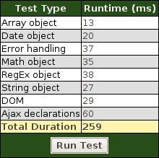
Firefox:
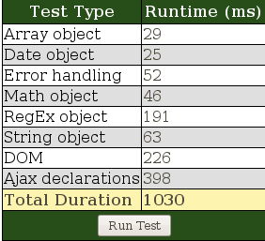
Midori:
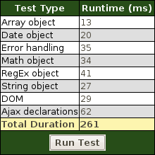

Conclusion

Spry was a lot faster(1.62 times on Sunspider) than Firefox and 4x faster on CelticKane
Used a lot less memory than Firefox
Spry and Midori were very close
Spry beat Midori by small margins in memory and speed

